Study Guide Chapter 1
Name:
Period:
Label the microscope with the following terms and state their functions
- Arm
- Base
- Course adjustment knob
- Diaphram
- Eye Piece
- Fine Adjustment
- High power Objective Lens
- Low power Objective Lens
- Stage
- Stage Clips

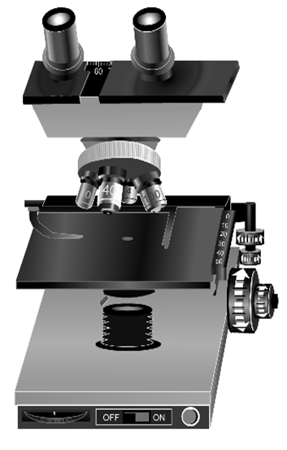
11. Define dependant variable.
12. List the steps of the scientific Method

13. Make a flow map of how to focus the microscope

14. Uses all 5 sences. _____________________
15. Always put on the X-axis. ______________
16. Data of numbers _________________
17. Ocular magnification __________________
18. If…. Then…. __________________
Marshmallow Muscles
Larry was told that a certain muscle cream was the newest best thing on the market and claims to
double a person’s muscle power when used as part of a muscle-building workout. Interested in this product, he buys the special muscle cream and recruits Patrick and SpongeBob to help him with an experiment. Larry develops a special marshmallow weight-lifting program for Patrick and SpongeBob. He meets with them once every day for a period of 2 weeks and keeps track of their results. Before each session Patrick’s arms and back are lathered in the muscle cream, while Sponge Bob’s arms and back are lathered with the regular lotion.

19. Which person is in the control group?

20. What is the independent variable?

21. What is the dependent variable?

22. What should Larry’s conclusion be?
23. Describe when you would use a line graph. Create a data table and graph showing a line graph. Be sure to use the correct scale and title the x-axis and y axis. Label what parts would be different on a line graph and why.

24. Create a flow map of the steps to make a wet mount slide.

